UCSC Meal Builder App User Manual

**Home Menu**

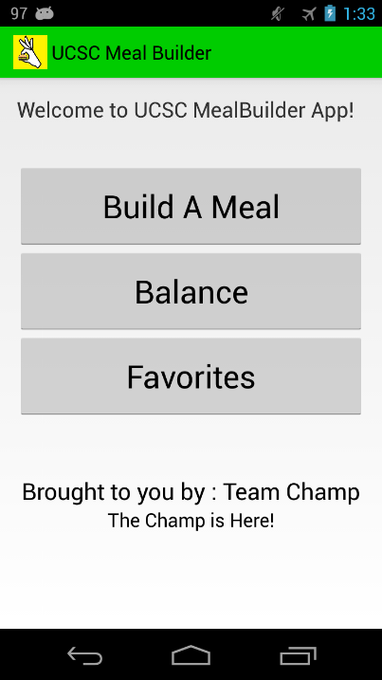This is the Welcome Screen of the UCSC Meal Builder App, where you can chose Build a Meal, Balance, or Favorites.

**Build A Meal:** Choosing this will take you to the list of restaurants and your first step on building your own meal.

**Balance:** This tab takes you to view your current balance.

**Favorites:** Choosing this will take you to the Favorites screen where you can see your previous saved meals.

In any other part of the app select this icon will send you back to the Welcome Screen.

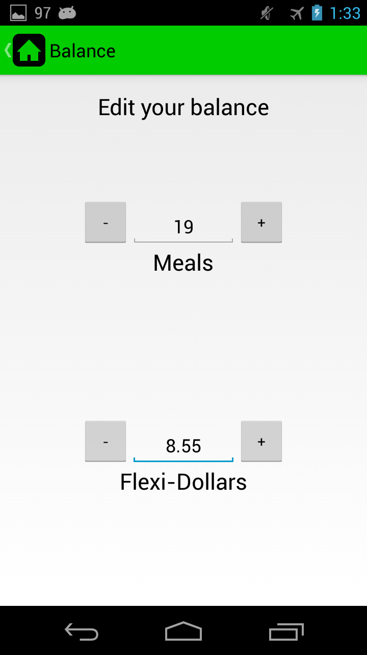**Balance Screen**

In this screen you can keep track of your meals and flexis to be used in the app. You can edit your meals and flexis.

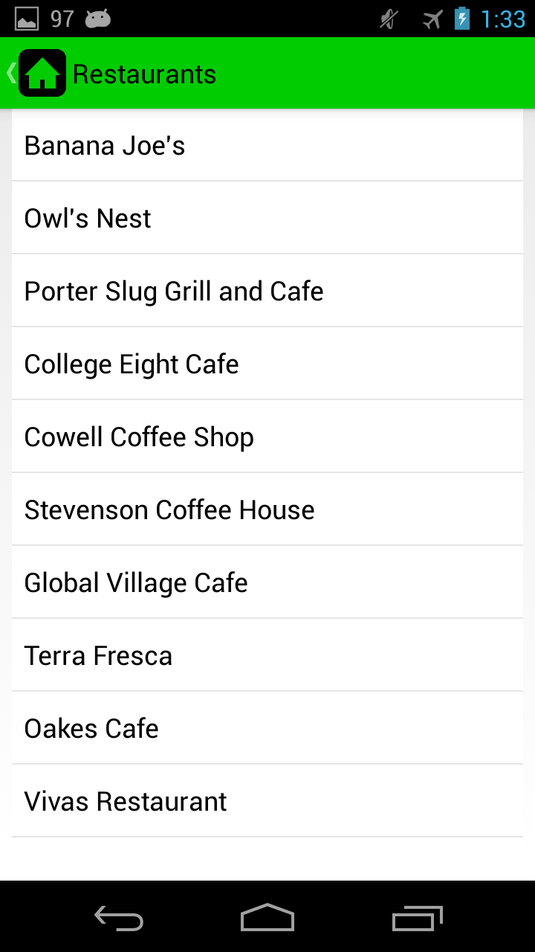**Restaurant Screen**

After choosing **Build A Meal** it will take you to the **Restaurant Screen**. Here you can choosing from a list of on campus eateries you would like to go to.

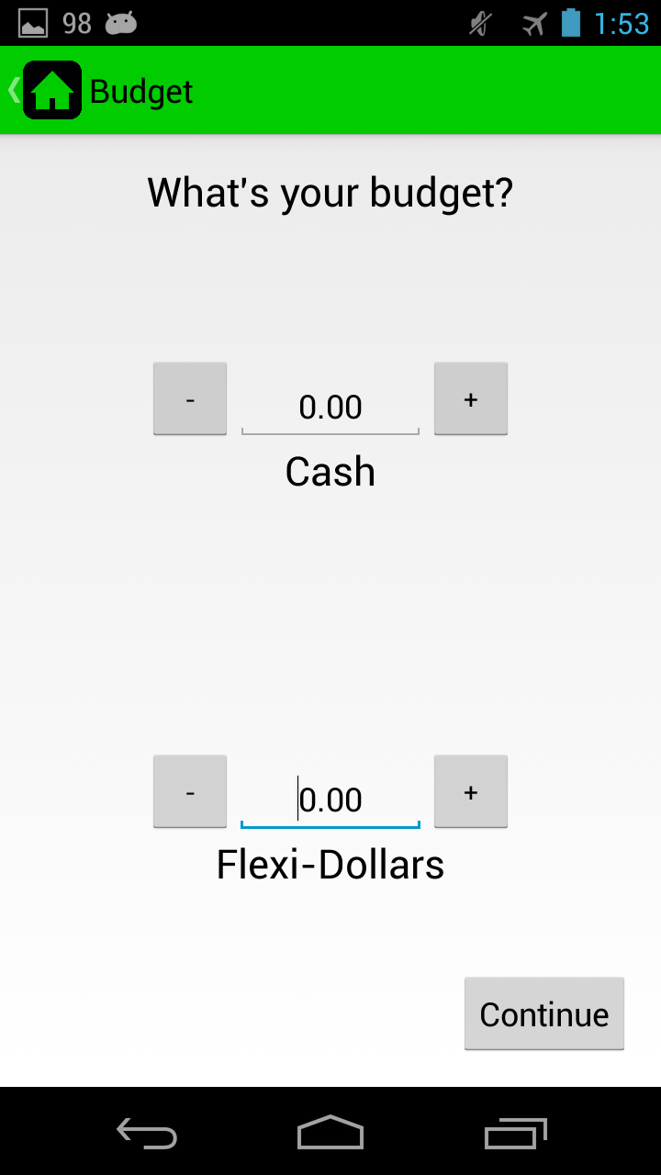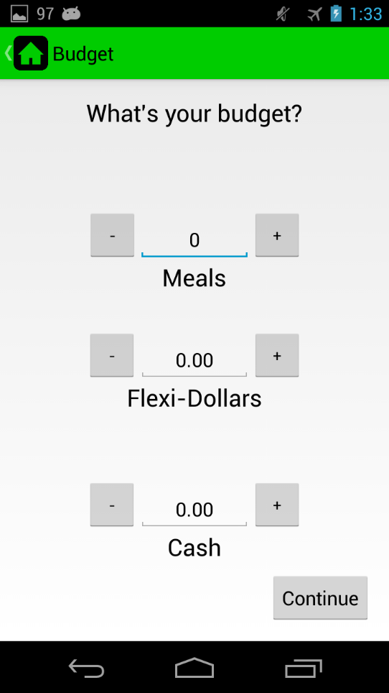**Budget Screen**

After selecting which restaurant you would like to dine at, depending on which restaurant you have picked one of two **Budget Screen** will appear where one will accept meals and the other does not.

**Meals:** You can enter the amount of meals you would like to use at this eatery.

**Flexi-Dollars:** You can enter the amount of flexi-dollars you would like to use at this eatery.

**Cash:** You can enter the amount of cash you would like to use at this eatery.

**Note:** **Meals** and **Flexi-Dollars** will be subtracted from your **Balance**. Also on calculation of balance **Meals** are prioritized over **Flexis** and **Flexis** are prioritized over cash.

**Menu Screen**

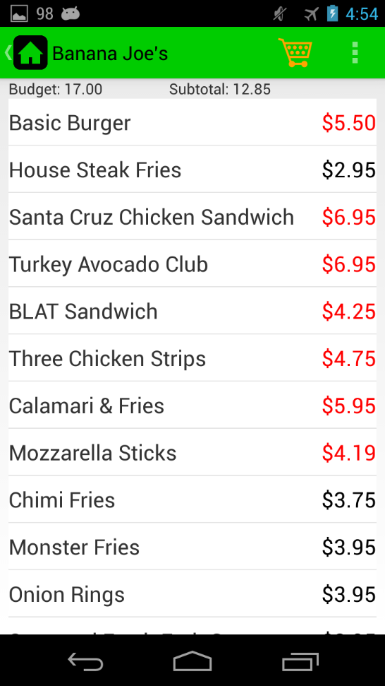After enter your **Budget** you will be brought to the respective restaurant menu.

**Budget:** This shows you how much money you are able to use.

**Subtotal:** This shows you the subtotal of the items you have added to your cart.

**Cart Button:** Selecting this will take you to the cart with items you have selected.

**Sorting the Menu:** Choosing this will allow you to sort the menu from A-Z, lowest - highest or highest – lowest, or by category

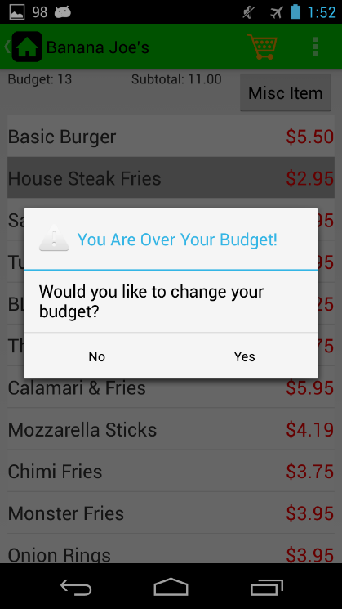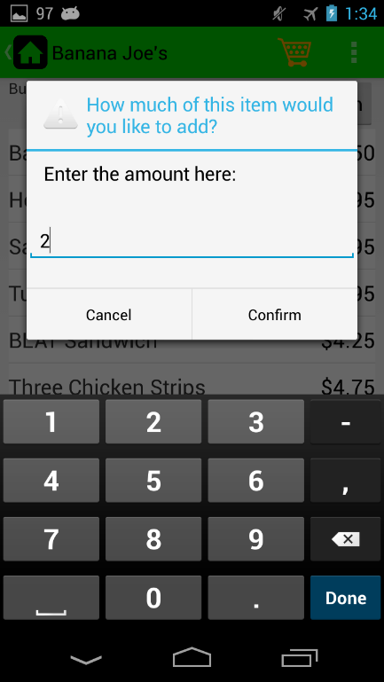**Entering into the Cart:** When tapping an item you will be prompted to add how much of an item you would like to add.

**Over your Budget! :** When items are over your budget the price is colored red and if select you would be prompted if you would like to change your budget to add it.

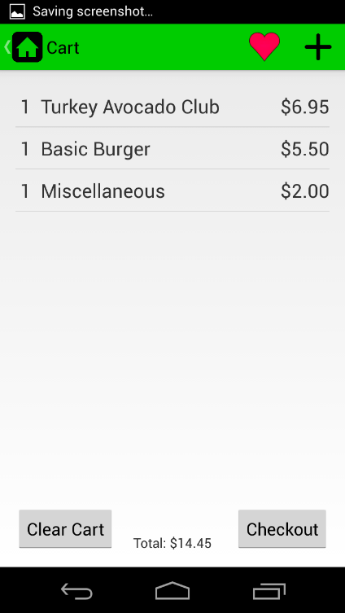**Cart Screen**

This is where you can see the items you have added from the menu screen. Each item is shown with a quantity amount next to it and the total of the meal on the bottom.

**+:** Use this to add miscellaneous items that are not on the menu.

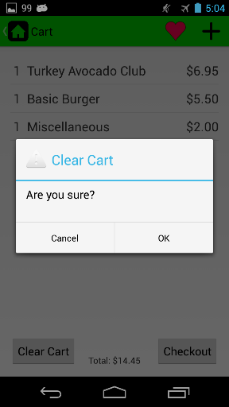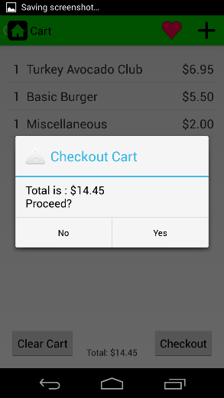

**Checkout**: Use this if you are satisfied with your meal and you would like to subtract it from your balance.

**Clear Cart:** Use this to clear your entire cart. (Each item can be cleared separately by tapping them.)

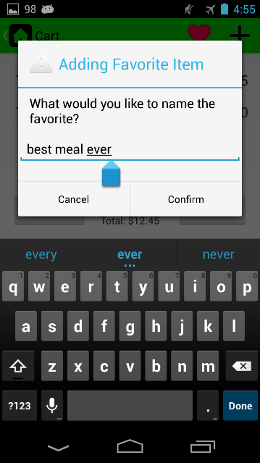

**Favorites:** If you like the meal you have constructed then you can name it and add it to your favorites.

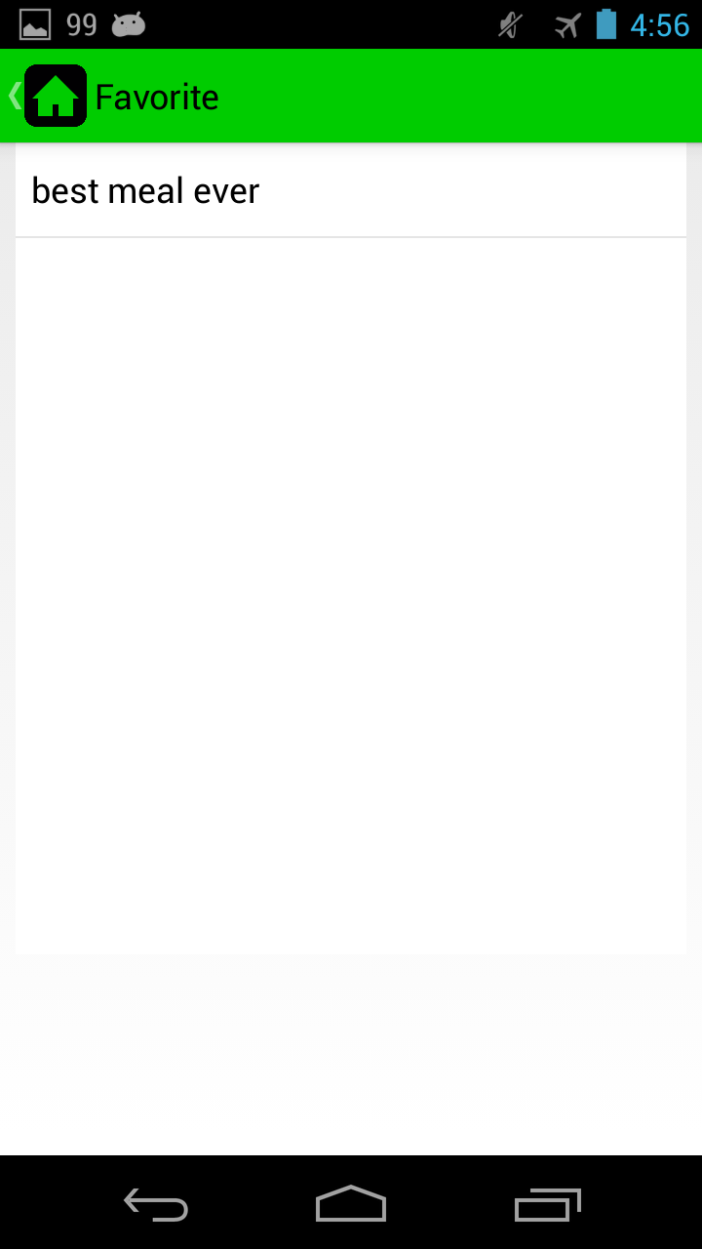

**Favorite Screen**

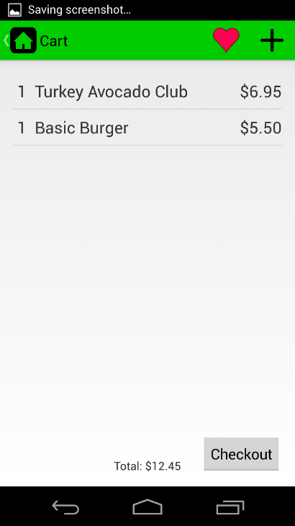In the favorite screen you can see the saved meals you have made. Once selecting the favorite it will take you into the cart screen with the items loaded so you can see them and checkout.

Note: Miscellaneous items are not saved when favorited